P.O. Box 969, Granby, CO 80446
info@habitatgrandcounty.org
970-887-9138

Getting back on track, helping Grand County families

Hello Habitat for Humanity - Grand Count supporters! We would like to update you on all the exciting changes taking place with our organization. This has been a year of challenges and changes for HFH - GC. We had a change in leadership with our Executive Director leaving in late summer. We plan to start a search for a new Executive Director soon, but in the meantime the Board of Directors has taken over and regained good standing status with HFH - International, re-established charitable organization status with the Colorado Secretary of State, improved bookkeeping procedures to provide timely and accurate deposit of funds and payment of bills, and improved financial procedures in preparation for an audit.
As we wait for the spring/summer building season to arrive, we are helping other Grand County families with smaller home improvement projects. We have replaced the windows in Karen Colla’s house, greatly improving the energy efficiency.
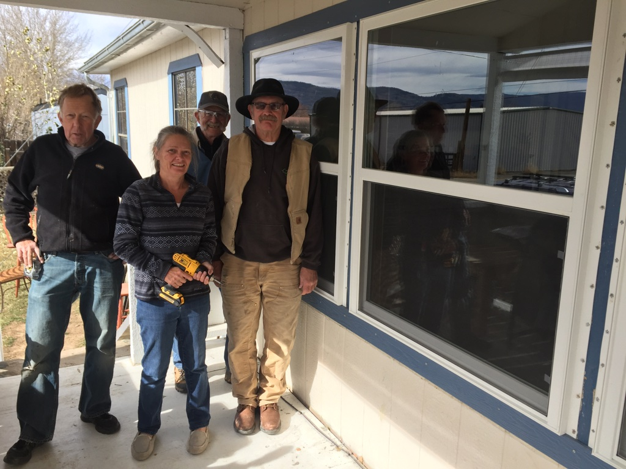Pictured above is Karen with HFH-GC Construction Manager, George Davis, and HFH-GC Board Members and volunteers, Chuck Chladek and Dick Schamberger.
In the Spring of 2018, we plan to build a house in Hot Sulphur Springs on the property that we own on the east side of town. Our Habitat volunteers are very excited to be building again – our 12th Habitat house in Grand County. Getting ready to start this house has taken time and resources. HFH - GC replaced the sewer line to the 7 lots that we own, and installed electrical lines and transformers, so that house construction can begin. Now that the infrastructure is completed we will be able to start the house, and be ready to start the second, third, and fourth houses on this property in future years. But we need your help with funding the next house, and helping another hard - working Grand County family to realize the dream of becoming homeowners.
We have the plans drawn up for this 12th house and we will start calling for volunteers in the next few months. On behalf of the Colla family and Habitat for Humanity of Grand County, we thank you for your continuing support. Please look into your heart and make a difference in the life of a family by continuing your support in 2017.
Your gift is the means by which we can continue to help families in Grand County realize their dreams of a home of their own in which to live and thrive.
God’s blessings to you and your family this holiday season!

Steve Morrison
President of the Board
Habitat for Humanity - Grand County
info@habitatforhumanity.org

-----------------------------------------------------------------------------------------------------------
Yes, I will help make a family’s dreams of a home of their own come true!
My gift is _____ square feet of a Habitat house ($100/square foot); ___$200 ___$150 ___$100 Other $_______.
Please make your check payable to Habitat for Humanity of Grand County and return with this slip in the enclosed envelope.

Please contact me about volunteering to help make dreams come true. _______
Please contact me about donating land for a future Habitat house. _______

Name:_____________________________________________________
Address:___________________________________________________
Phone Number:_____________________________________________
My e-mail address is: ___________________________________________________________________
I would like to receive future mailings by e-mail so funds go to making dreams come true rather than postage. Yes no
HFH of Grand County is a 501(c)(3) organization. Gifts are tax deductible. We thank you for your generosity

